IoT technology stack
The IoT technology stack is nothing else than a range of technologies, standards and tools, which lead from the simple connection of objects to the applications that use these connected things, the data they gather and communicate and the different steps needed to power them.
- What is the IoT technology stack?
- What is the technology stack required to build an IoT App?
- The IoT technology stack refers to the range of technologies, applications and standards used to develop an IoT application.
- It encompasses everything required to build the application, transmit data and generate actionable alerts or other necessary insights.
- It might look simple, but it involves different layers of several technologies for an IoT project.
- Moreover, it’s not just about combining the right technologies but also doing it in an accurate, secure and cost-effective way.
- IoT layers for developing IoT Stack
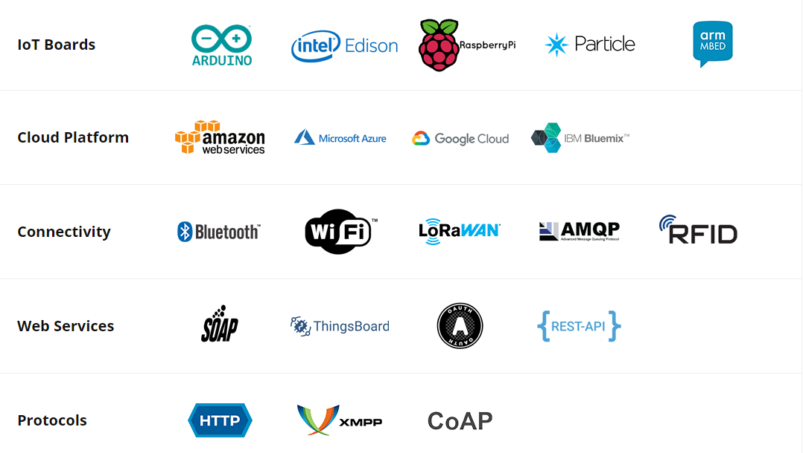

IoT Platforms
AWS IoT
- AWS IoT offers services for industrial, consumer and commercial solutions.
- Billions of devices in factories, homes, oil wells, cars, hospitals and thousands of other places can interconnect using AWS IoT and collect, store and analyze device data.
- AWS IoT provides the following benefits:
- Broad and deep: AWS offers wide and deep IoT services from the edge to the cloud.
- It is the only cloud vendor that provides both data management and rich analytics for noisy IoT data.
- Multi-layered security: AWS IoT provides complete protection that includes preventive security mechanisms such as encryption, access control and continuous monitoring and audit configurations.
- Superior AI integration: AWS combines Artificial Intelligence with IoT to make devices more intelligent.
- It allows creating models in the cloud and deploying them to devices that run faster than other offerings.
- Proven at scale: Built on secure and proven cloud infrastructure, AWS IoT can scale to billions of devices.
- It integrates with other AWS services to provide complete solutions.
AWS IoT services include:
Device software
- Free RTOS: It is an operating system for microcontrollers that allow easy programmability, deployment, security, connectivity and manageability of small, low-power edge devices.

{Real Time Operating System (RTOS)
- Real-time operating systems (RTOS) are used in environments where a large number of events, mostly external to the computer system, must be accepted and processed in a short time or within certain deadlines.
- Such applications are industrial control, telephone switching equipment, flight control, and real-time simulations.
- With an RTOS, the processing time is measured in tenths of seconds. This system is time-bound and has a fixed deadline.
- The processing in this type of system must occur within the specified constraints. Otherwise, this will lead to system failure.

Examples of the real-time operating systems: Airline traffic control systems, Command Control Systems, Airlines reservation system, Heart Pacemaker, Network Multimedia Systems, Robot etc.
The real-time operating systems can be of 3 types –
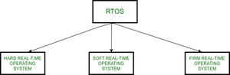

- Hard Real-Time operating system:
These operating systems guarantee that critical tasks be completed within a range of time.
For example, a robot is hired to weld a car body. If the robot welds too early or too late, the car cannot be sold, so it is a hard real-time system that requires complete car welding by robot hardly on the time.
- Soft real-time operating system:
This operating system provides some relaxation in the time limit.
For example – Multimedia systems, digital audio systems etc. Explicit, programmer-defined and controlled processes are encountered in real-time systems. A separate process is changed with handling a single external event. The process is activated upon occurrence of the related event signaled by an interrupt.
Multitasking operation is accomplished by scheduling processes for execution independently of each other. Each process is assigned a certain level of priority that corresponds to the relative importance of the event that it services. The processor is allocated to the highest priority processes. This type of schedule, called, priority-based preemptive scheduling is used by real-time systems.
- Firm Real-time Operating System:
RTOS of this type have to follow deadlines as well. In spite of its small impact, missing a deadline can have unintended consequences, including a reduction in the quality of the product. Example: Multimedia applications.

Advantages:
The advantages of real-time operating systems are as follows-
- Maximum consumption –
Maximum utilization of devices and systems. Thus, more output from all the resources.

- Task Shifting –
Time assigned for shifting tasks in these systems is very less. For example, in older systems, it takes about 10 microseconds. Shifting one task to another and in the latest systems, it takes 3 microseconds.
- Focus On Application –
Focus on running applications and less importance to applications that are in the queue.
- Real-Time Operating System In Embedded System –
Since the size of programs is small, RTOS can also be embedded systems like in transport and others.
- Error Free –
These types of systems are error-free.
- Memory Allocation –
Memory allocation is best managed in these types of systems.
Disadvantages:
The disadvantages of real-time operating systems are as follows-
- Limited Tasks –
Very few tasks run simultaneously, and their concentration is very less on few applications to avoid errors.
- Use Heavy System Resources –
Sometimes the system resources are not so good and they are expensive as well.
- Complex Algorithms –
The algorithms are very complex and difficult for the designer to write on.
- Device Driver and Interrupt signals –
It needs specific device drivers and interrupts signals to respond earliest to interrupts.
- Thread Priority –
It is not good to set thread priority as these systems are very less prone to switching tasks.
- Minimum Switching – RTOS performs minimal task switching.
- }
- AWS IoT Greengrass: It is software that allows running local messaging, data caching, syncing and machine learning interface capabilities on connected devices in a secure manner.
Connectivity and control services
- AWS IoT Core: It enables devices to quickly and securely interact with cloud applications and other devices.
- AWS IoT Device Defender: It continuously monitors and audits IoT configurations to ensure that security best practices are followed and met.
- AWS IoT Device Management: It allows registering quickly, monitoring, organizing, and remotely managing IoT devices at scale.
Analytics services
- AWS IoT Analytics: It helps to run sophisticated analytics on vast volumes of IoT data.
- AWS IoT SiteWise: It helps in industrial data collection, organization and analysis at scale.
Azure IoT
- Azure IoT allows IoT devices to connect to the cloud, perform analysis on the collected data and take actions based on generated insights.
- It is a scalable and secure IoT platform. Azure IoT services include:
Connectivity and analytics
- Azure IoT Hub: It allows connection, management, and scale of several IoT devices from edge to cloud.
- Azure IoT Central: Azure IoT Central supports the creation of IoT solutions.
- It effectively helps to reduce the burden and cost of IoT operations and development.
- Time series insights: It helps to gain actionable insights by analyzing the data collected by IoT devices.
Edge and device support
- Azure IoT Edge: It extends cloud intelligence and analytics by transferring workloads and business logic from cloud to edge devices.
- Windows IoT: It provides long-term OS services and supports to manage devices.

Google Cloud IoT Core
- Google Cloud IoT platform allows predicting when equipment needs maintenance automatically.
- It also optimizes devices’ performances in real-time while detecting anomalies, indicating downtime and tracking device state, location and status.
- The key features of Google Cloud IoT include:
- predictive maintenance
- real-time asset tracking
- support logistics and supply chain management

IoT devices and connected physical objects
Temperature sensors
- These sensors are used to monitor the heat energy at a particular source and identify temperature changes.
- For example, temperature sensors in the vaccine palette help to monitor temperature changes and maintain the vaccines at the required temperature throughout their supply chain.
Humidity sensors
- These sensors are used to measure the amount of water vapor in the surrounding.
- Humidity sensors are generally installed heating systems, ACs and vents in homes and factories to check humidity levels.
Gyroscope
- It is used for measuring and maintaining the orientation and angular velocity.
- It is used in-car navigation systems, camera shake detection systems and motion detection for video games.
Accelerometers
- Accelerometers are used to measure the object’s velocity change rate concerning time, which is nothing but an object’s acceleration.
- It is widely used in anti-theft systems that send alerts when a stationary object starts to move from its fixed location.
- It is also used in fleet monitoring and intelligent pedometers.

Communication methods for data transmission
Wifi
- Wifi is the most significant IoT communication protocol used for the LAN environment that supports quick data transfer.
- However, it provides high data transfer speed but consumes a lot of power for IoT applications.
Bluetooth
- Bluetooth technology is best suited for short-range communications.
- It is highly used for mobile devices, consumes less power and is scalable to all market innovations.
LoRaWAN
- It stands for Long Range Wide Area Network, most widely used for long-range wireless battery-enabled devices.
- It helps to detect signals below the noise level and is used in smart cities to connect millions of devices.
LPWAN
- LPWAN is a wireless telecommunication area network used for long-range communications at a low bit rate.
- It runs on small batteries and usually works over more than 2 km.
- Most widely, it is used for Smart Lighting, Smart grids and asset tracking.
Zigbee
- ZigBee is a short-range wireless communication protocol that consumes low power, provides security, durability and scalability.
- ZigBee operates on the frequency of 2.4GHz with a data speed of 2500 kbps.
- ZigBee works over 200 meters and implements 128 AES encryption over a full 1024 nodes in the network.
A successful IoT solution entails selecting each component carefully. The technology stack is an essential part of the overall IoT solution. Businesses must ensure to make the informed decision based on their specific requirements. Therefore, it is essential to consider what is required to develop an IoT app solution.

The 5 Layers of the IoT Technology Stack

- You’ve probably heard a lot about how the Internet of Things (IoT) will revolutionize many areas of our life.
- And even with all this potential, many Product Managers are still struggling to understand the basic concepts of IoT and how they can use it to provide additional value to their customers and company.
- When getting started with IoT, it’s easy to be intimidated by the complexity, the jargon, and the hype.
- But there’s nothing to worry about.
- The first step is to stop looking at IoT as a black box and start looking at it as a system comprised of a few distinct technology blocks.
- I call these blocks the 5 layers of the IoT Technology Stack.
- Once you get familiar with the IoT technology stack, you’ll see that there’s nothing magical about IoT.
- It’s just sensors, computers, and networks put together.
- By the way, all IoT products have these 5 layers, regardless of whether they are consumer or industrial products.

Introducing the 5 Layers of the IoT Technology Stack
- The first step to becoming an IoT Product Manager is to understand the five layers of the IoT technology stack.
- By breaking down a full IoT solution into these five layers, Product Managers can better understand and analyze the business and technology tradeoffs that are needed at each level, and in the system as a whole.
- These five layers are:
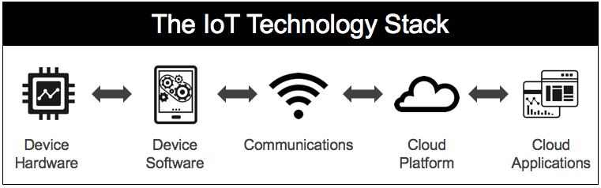
7- layer -IoT Protocol Stack Layers
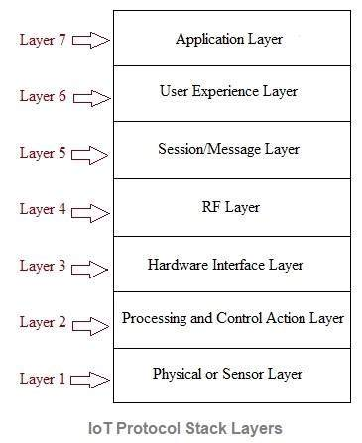
- To put this IoT technology stack in context, let’s imagine you’re developing a product that monitors the health of a wind turbine.
- This product anticipates when the turbine needs maintenance, thereby saving millions of dollars in potential damage to the turbine and avoiding interruption of service.
- This technique is commonly known as “predictive maintenance.”
- Now let’s use the wind turbine example to describe in detail each of the layers of the IoT technology stack.

Layer 1 – Device Hardware
- Devices constitute the “things” in the Internet of Things.
- Devices act as the interface between the physical and digital worlds.
- They are the first layer of the IoT technology stack.
- The first thing to consider is whether your product is the connected device itself (i.e., the Nest thermostat) or your product is turning an existing device into a connected device by adding instrumentation (i.e., adding sensors and communication to a wind turbine).
- One of the main goals of our device is to collect data.
- So next, you need to think about what data to collect and, therefore, what device hardware you need to do that.
- For simple data collection needs, you may need only one sensor.
- For more complex data collection, you may need an industrial computer that houses many sensors, a powerful processor, local storage, a gateway, etc.
- In this layer of the IoT technology stack, it’s essential to understand hardware parameters such as cost, size, ease of deployment, reliability, useful lifetime, etc.
- For example, for small devices like smartwatches, you may only have physical space for a System on a Chip (SoC).
- For more demanding solutions, you may need an embedded computer like Raspberry Pi, Arduino, or BeagleBone board.
- For critical computing needs, you may need advanced industrial computers like compact RIO or PXI.
- All of these solutions have different requirements around cost, size, battery life, etc.

Layer 2 – Device software
- The device software is the component that turns the device hardware into a “smart device.”
- Device software is the second layer of the IoT technology stack.
- Device software enables the concept of “software-defined hardware,” meaning that a particular hardware device can serve multiple applications depending on the embedded software it is running.
- Device software allows you to implement communication with the Cloud or other local devices.
- You can perform real-time analytics, data acquisition from your device’s sensors, and even control.
- This layer of the IoT technology stack is critical because it serves as the glue between the real world (hardware) and your Cloud Applications.
- It’ll be up to you and your team to decide how much functionality you place here versus in the Cloud.
- You can also use device software to reduce the risks of hardware development.
- Building hardware is expensive, and it takes a lot longer than software.
- So instead of building your device for a narrow and specific purpose, it’ better to use generic hardware that can be customized by your device software to give you more flexibility down the road.
- This technique is often known as “software-defined hardware.”
- This way, you can update your embedded software remotely via the Cloud, which will update your “hardware” functionality in the field.
I divide the device software layer into two categories:

Device Operating System
- The complexity of your IoT solution will determine the type of Device Operating System (OS) you need.
- Some of the key considerations include whether your application requires real-time processing, the type of I/O support you need, and whether you need support for the full TCP/IP stack.
- Common examples of embedded operating systems include Linux, Brillo (scaled-down Android), Windows Embedded, and VxWorks, to name a few.

Device Applications
- Device applications run on top of the Edge OS and provide the specific functionality for your IoT solution. Here the possibilities are endless.
- You can focus on data acquisition and streaming to the Cloud, analytics, local control, etc.
- For our wind turbine monitor example, our accelerometer will be taking frequent samples to measure vibration. This produces an enormous amount of data. But we don’t need to send all that data to the Cloud—just the data that indicates there’s a problem. Therefore, our device application software will be monitoring the data locally and will only send warning and error conditions. It will also perform real-time control to shut down the turbine if the vibration goes out of the parameters you specify.
- Product Manager tip: If device hardware and software work together to create a smart device, why represent them separately in the IoT Technology stack?
- It’s helpful to think of them separately because they are built by different teams using very different requirements, processes, and timelines.
- Device software will be developed by software engineers using an Agile approach.
- Devices, on the other hand, will be developed by a hardware engineering group following a hardware NPI process.
- This separation will make your job much more comfortable as you plan roadmaps and work with various teams.

Layer 3 – Communications
Communications refer to all the different ways your device will exchange information with the rest of the world. Communications are the third layer of the IoT technology stack. Depending on your industry, some people refer to this layer of the IoT technology stack as “connectivity.” In this post, I’m using the more generic term “communications,” but I’m referring to the same thing.
Communications include both physical networks and the protocols you will use. It is true that the implementation of the communications layer is found in the device hardware and device software. But from a conceptual model (not implementation model), I prefer to keep Communications as its own layer in order to facilitate discussions with the rest of my team.
Selecting the right communication mechanisms is a critical part of your IoT product strategy. It will determine not only how you get data in and out from the Cloud (for example, using Wi-Fi, WAN, LAN, 4G, 5G, LoRA, etc.), but also, how you communicate with third-party devices in the same building.
For example, it is common for systems in smart buildings to communicate with each other using the BACnet protocol. If your device is involved in building automation, it’s a good idea for your device to provide BACnet support, even if you’re not sure yet whether you want your device to talk to other devices in the building.
Your communication strategy has an impact on the overall topology of your system. For example, if your IoT solution has ten sensors, should each sensor communicate directly to the Cloud? Or should you have ten simpler (and cheaper) sensors that communicate to a central gateway for aggregation and long-range transmission of data?
These decisions are not purely technical. These are business decisions that Product Managers need to make while considering the impact to cost, deployment, and technical complexity of the solution.
For my wind turbine monitor example, the first inclination might be to connect the devices to a local area network. But the wind farm might be in the middle of nowhere, and all you have is a nearby cell phone tower. So you will have to connect to the Cloud via cellular communication.
This decision will have implications on your selection of device’s hardware and software, and on your cost because you will have to pay a cellular service provider for the connection. This additional cost also supports our decision to pre-analyze sensor data in the device and only send actionable insights to the Cloud as opposed to sending the entire data set produced by the accelerometer, Remember, the more data you transmit, the more it costs you.

Layer 4 – Cloud Platform
The cloud platform is the backbone of your IoT solution. If you are familiar with managing SaaS offerings, then you are well aware of the role of this layer of the IoT technology stack.
A Cloud platform provides the infrastructure that supports these critical areas:

Data Collection and Management
Your smart devices will stream information to the Cloud. As you define the requirements of your solution, you need to have a good idea of the type and amount of data you’ll be collecting on a daily, monthly, and yearly basis.
One of the challenges of IoT applications is that they can generate an enormous amount of data. You need to make sure you define your scalability parameters so that your architects can determine the right data management solution from the very beginning.
Recommended article: Big Data: 6 Key Areas Every Product Manager Should Address

Analytics
Analytics is one of the critical components of any IoT solution. By analytics, I’m referring to the ability to crunch data, find patterns, perform forecasts, integrate machine learning, etc. It is the ability to find insights from your data and not the data alone that makes your solution valuable. Analytics can be as simple as data aggregation and display or can be as elaborate as using machine learning or artificial intelligence. There’s no right or wrong here. Your customer’s needs will inform what type of analysis you’ll need to perform in order to solve their need.

Cloud APIs
The Internet of Things is all about connecting devices and sharing data, which you can achieve by exposing APIs at either the Cloud level or the device level. Cloud APIs allow your customers and partners to either interact with your devices or to exchange data. Remember that opening an API is not a technical decision; it’s a business decision.
Product Managers need to provide their teams a clear direction of the overall IoT solution so that the technical teams can determine the right Cloud architecture. Product Managers also need to evaluate the cost and complexity of the development of the Cloud platform via a build versus buy analysis.
Every technical team inclines to build a complete solution from the ground up. But regardless of whether the team is capable of doing it or not, it’s essential for the Product Manager to determine if building your Cloud platform makes “business sense” not only from the development perspective, but also considering the total cost of ownership, maintenance, support, reliability, and time to market.
In many cases, it might be better to leverage existing PaaS (Platform as a Service). There are many in the market, so for a deeper dive into the Cloud platform layer of the IoT technology stack, I recommend my article:
For our wind turbine monitoring example, let’s think about how much data we’ll have to store. The data from one turbine might not seem like a lot. But over the years, it will add up. Plus, remember that your Cloud platform needs to support data from thousands of wind turbines. In time, this will be an enormous amount of data, so our Cloud infrastructure needs to allow for flexible storage and processing of this data.
Additionally, your Cloud analytics might need to process incoming data in real-time to detect trends and be able to make predictions of when the turbines will need service. You might also need to open an API to surface this information to your application layer.

Layer 5 – Cloud Applications
This fifth layer of the IoT technology stack is the most easily understood by Product teams and Executives. Your end-user applications are the part of the system that your customers will see and interact with. These applications will most likely be web-based, and depending on your user needs, you might need separate apps for desktop, mobile, and even wearables.
Even if your smart device has its own display, your customer is very likely to use a cloud application as their main point of interaction with your solution. This allows them to have access to your smart devices anytime and anywhere, which is part of the goal of having connected devices.
Product Managers must understand your users and the “job to be done” of your product. When designing your end-user applications, it is very important to understand who is your user is and what their primary goal of using your product. Keep in mind that for Industrial IoT applications, you’ll probably have more than one user.
Applications can also be divided into customer-facing versus internal apps. Customer-facing applications usually get the most attention, but in the case of IoT, internal applications are equally important. These include applications to remotely provision and troubleshoot devices, monitor the health of your device fleet, report on performance and predictive maintenance, etc.
These internal applications will require a deep understanding of your external and internal customers and will require the right prioritization and resourcing to make sure they don’t fall through the cracks. They are a key component of an IoT solution, so it’s the Product Manager’s responsibility to ensure they get done.
For our wind turbine monitor, one possible application would be a web app used by wind farm operators working in a central control room. This app displays information and trends on the thousands of turbines that they manage and alerts them when a particular turbine needs service. The operator can get this information in real-time and dispatch the service team to perform preventive maintenance, avoiding costly repairs and service interruptions.

What about “the Edge”?
You’ve probably heard the term “edge” thrown around alongside IoT. Edge refers to “edge computing,” which is the ability to perform analytics or some other computational work closer to where your sensors are.
The question I often get is: Why didn’t you include the edge as one of the layers of the IoT technology stack? That’s a great question! And the answer is just: simplicity.
In this post, I’m presenting a conceptual model of the IoT Technology Stack to help you in conversations with all your stakeholders and customers.
This generic model is not intended as an exact engineering representation of an IoT solution. That’d increase the complexity and defeat the purpose of having a simple communication tool.
Another reason is that the definition of “edge” changes depending on who you are talking to. For example, depending on the vendor, the edge can be:
- The device itself
- A gateway
- An on-premise server that collects data before connecting to the Cloud
- The edge of the cellular network or “Telco edge” if you are talking to Telecommunication providers
- The edge of the electric grid (i.e., smart meters) if you are talking to Utilities
As you can see, the definition and interpretation vary. My recommendation is to keep it simple and use these 5 layers of the IoT technology stack.
But, if you need to add the edge for clarity, you can modify my diagram to add the necessary layers that better represent your solution. The goal is to have a conceptual model that YOU can use to communicate with all your stakeholders.

The IoT Technology Stack Is a Communication Tool
How should you use this model of the 5 layers of the IoT Technology Stack? Use it as a communication tool.
As Product Managers, we need to interact with many people in our organization as well as customers and partners. I’ve found that the first challenge is getting everybody on the same page. That’s where this tool comes into play.
Every time I talk to new groups, I flash the IoT Technology Stack to make sure everybody understands what I’m talking about when I say IoT or end-to-end IoT solutions. It gives everybody a frame of reference AND a common language to refer to the various building blocks. It eliminates the “black box” approach to IoT and puts it in terms everybody can understand.
I include this IoT Technology Stack in most of my presentations (internal and external), and I often open every meeting by aligning everybody on the 5 layers and then on the specific one we’ll be focusing on for this meeting.
It helps me anchor discussions not only with the technical team but also with sales, marketing, executives, design, data science, compliance, vendors, etc.
Now that you are familiar with the IoT Technology Stack, I highly recommend reading my article on The IoT Decision Framework. It’ll give you the next level of tools to approach IoT Product Management in a structured way.

The Bottom Line
As the Internet of Things continues to grow, the world will need an army of IoT-savvy Product Managers. And those Product Managers will need to understand each layer of the IoT Technology Stack, and how they all fit together into a complete IoT solution.
Product Managers will need to make strategic business and technical decisions at each layer to ensure the success of their products.
Quick favor. If you enjoyed this article, then it’d be a HUGE help if you shared it with other product folks.
Where do you go from here? Read my next post, where I share an IoT Decision Framework. My framework builds on top of the IoT Technology Stack to give you a structured method to develop your IoT product strategy and roadmap.

IoT Protocol Stack Layers | IoT Stack Layer 1 to Layer 7
This page on IoT Protocol Stack Layers describes functions of IoT Stack Layer 1, Layer 2, Layer 3, Layer 4, Layer 5, Layer 6 and IoT Layer 7.
Lile other wired and wireless technologies, IoT (Internet of Things) also has protocol layers from layer 1 to 7. We have seen OSI (Open System Interconnection) model which defines 7 layer networking framework. OSI defines functions of each of these layers and their interfaces.
Let us understand functional description of 7 layers of IoT protocol stack as shown in the figure below.
IoT stack consists of following seven layers viz. Sensor layer, processing/control layer, hardware interface layer, RF layer, session/message layer, user experience layer and application layer.

IoT Stack Layer 1
Physical or sensor layer:
Similar to OSI physical layer, this IoT layer 1 interfaces with physical components. The physical components are mainly sensors such as humidity sensor, temperature sensor, pressure sensor, heartrate sensor, pH sensor, odour sensor etc. The sensors are used for sensing of various parameters as per application of use. There are plenty of sensors available for same functionality and hence appropriate selection of sensor is done based on cost and quality. It is this layer-1 which provides sensed data to IoT stack for further processing.

IoT Stack Layer 2
Processing and control layer :
The data provided by layer-1 using sensors are processed at this layer. Microcontroller/Processor and operating system play vital role at this layer. Various development kits can be used for this purpose such as Arduino, NodeMCU (based on ESP32 or ESP8266) , ARM, PIC etc. Typical operating systems used are Android, Linux, IOS etc.

IoT Stack Layer 3
Hardware Interface layer :
This layer include components or interfaces used for communication such as RS232, RS485, SPI, I2C, CAN, SCI etc. These interfaces are used for serial or parallel communication at various baud rates in synchronous/asynchronous modes. The above mentioned interface protocols ensure flawless communication.

IoT Stack Layer 4
RF layer :
This radio frequency layer houses RF technologies based on short range or long range and data rate desired by the application of use. The common indoor RF/wireless technologies include Wifi, Bluetooth, Zigbee, Zwave, NFC, RFID etc. The common outdoor RF cellular technologies include GSM/GPRS, CDMA, LTE-M, NB-IoT, 5G etc. RF layer does communication of data using radio frequency based EM waves. There is another technology which uses light waves for data communication. This light based data communication is referred as LiFi.

IoT Stack Layer 5
Session/Message Layer :
This layer deals with various messaging protocols such as MQTT, CoAP, HTTP, FTP (or Secured FTP), SSH etc. It defines how messages are broadcasted to the cloud. Refer architectures of MQTT protocol and CoAP protocol.

IoT Stack Layer 6
User experience layer :
This layer deals with providing best experience to the end users of IoT products. To fulfill this, this layer takes care of rich UI designs with lots of features. Various languages and tools are developed for the design of GUI interface softwares. These include objected oriented and procedure oriented technologies as well database languages (DBMS, SQL) in addition to analytics tools.

IoT Stack Layer 7
Application layer :
This layer utilizes rest of the six layers in order to develop desired application. The typical case studies or applications of IoT are as follows.
• Smart Home
• Smart Parking System based on zigbee, LoRaWAN and other wireless technologies.
• Smart Energy System, Refer Smart Grid Architecture.
• Smart City
• Smart lighting system based on zigbee standard
• Smart Retail
• Smart Agriculture farming
• Smart Waste Management
Conclusion:
Based on IoT application, appropriate layers and protocols/technologies are used at the 7 layers described above in an IoT protocol stack. Refer IoT stack vs Web stack >> for difference between IoT stack and Web stack.

Iot Technology Stack
by Itika SarkarApr 26, 2020Applications of IoT
In this post, IoT will again surprise you with its innovative features. This post is all about the technology stack of IoT. Therefore, to go deeper into this topic you should have a clear knowledge of technology stack and how it is linked with the IoT. So, what is a technology stack? It is nothing but a package of services that are needed to be run an application. Finally, coming to the subparts of this post.

Contents
- Introduction
- Technology Stack
- What is IoT technology stack
- Layers of IoT technology Stack
  - 1st
  - 2nd
  - 3rd
  - 4th
So, let’s get started.

Introduction
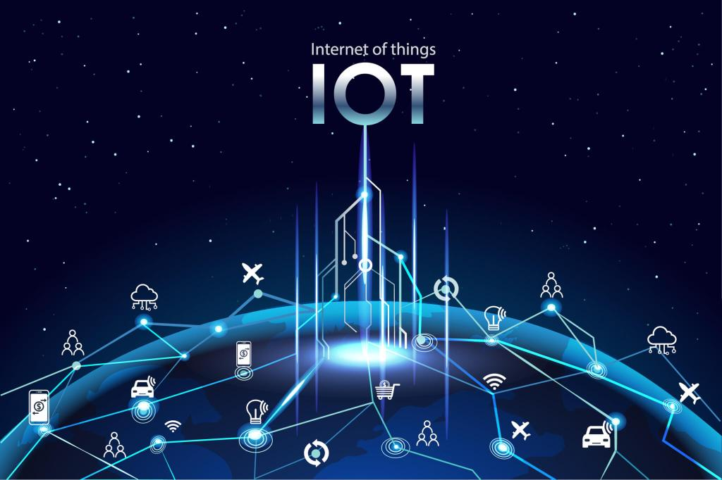http://analyticstraining.com/4-layers-of-the-internet-of-things/
Firstly, human being is by nature curious. So, every time human try to think the next big thing to innovate. As we all trying to make the changes in our near future rather trying to make life simpler and easier we are involving technologies. And, the Internet of Things is the platform of the current developing world which is enhancing day by day.
In addition, it is moderating by combining with the latest industry-related technologies. Likewise, IoT is combining with machine learning, artificial intelligence, deep learning, python programming language and many more. Basically, IoT is gathering its think stack and it is on a hike. Now, its time to differentiate its think stack which we will discuss here.

What is technology stack?
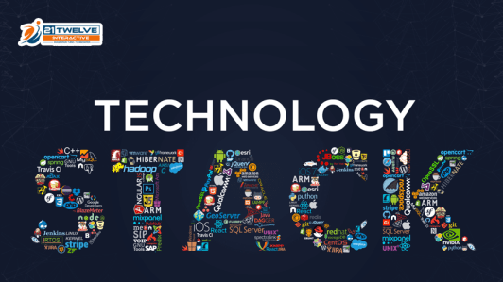http://www.21twelveinteractive.com/pick-best-technology-stack-product/
A technology stack is also called a data stack. It is nothing but a list of technology services that are used to run a single application. Likewise, Facebook is the combined application of languages like JavaScript, CSS, HTML, PHP, and ReactJS. Similarly, every application needs a technology stack of different layers.
Basically, the technology stack is a package of coding languages, development tools, and frameworks which interfaces with the application. So, the technology stack is solely dependant on the developers on how they want to connect their application.

What is IoT technology stack
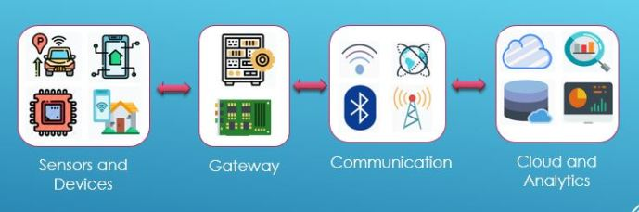Iot Technology Stack
Firstly, there are so many components that are required to build the complete “thing” package and drive to make solutions in IoT. Hence, IoT is a network of connected “things” which enables data exchange. Moreover, it creates an opportunity that enhances more direct integration of the physical world into computer-based systems. Therefore, efficiency, improvement, economical benefits, and reduced human exertions come parallelly.

Layers of IoT Technology Stack
Most importantly, IoT stack consists of four layers and these are discuss in below:

Sensors
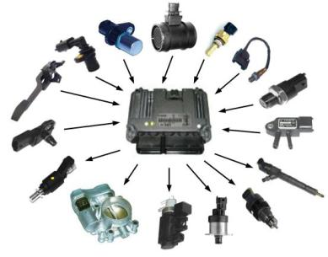http://www.thinglink.com/scene/726728677978537985
Firstly, this comes under the first layer of the IoT technology stack. So, sensors are the devices which enable to take the information or data from the physical environment to send it other electronic devices. In addition, the output of the sensors is an electrical signal. Here’s the list of sensors:
- Temperature sensor: Firstly, this sensor computes the changes in the temperature. Besides, they(LM35, Thermistors, Thermocouple, RTD) are used in computers, mobile phones, air conditioner systems, etc.
- Humidity sensor: So, as the name suggests humidity sensors are used to measure the humidity, relative humidity (and also some sensors like DHT11 can also able to measure the temperature).
- IR sensor: Firstly, IR sensors or Infrared Sensors are the proximity and object detection sensors. In addition, this is consists of an IR detector and IR transmitter.
- Ultrasonic sensor: Basically, It can measure the distance of the object by using the Doppler shift property of sound wave which is used to find the velocity of the object.
- Proximity sensor: Similarly, the proximity sensor also detects objects.
- Smoke/gas detector sensor: So, as this name suggests this sensor detects the existence of smoke or gas in the environment.
- Pressure sensor: Basically it can measure the pressure of the air in a particular area.
- Light sensor: This is the sensor that can detect the presence of light.
- Touch sensor: So, this sensor can sense the touch of the human hand.
- Rain sensor: This is the switch to inform whether it’s going to rain or not.
- Water flow sensor: This sensor detects the rate of flow of water.
- Soil moisture sensor: Basically, this informs whether the soil contains water or not.
- Chemical sensor: Firstly, this can detect the chemical quality in a substance. In addition, it converts the sensed chemical data to the electrical signal.

Actuators
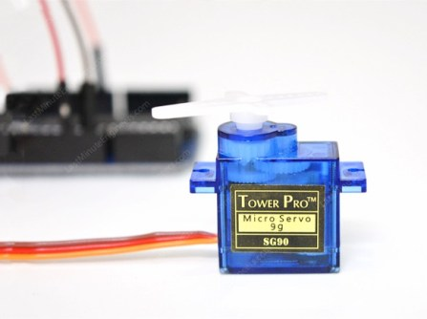http://lastminuteengineers.com/servo-motor-arduino-tutorial/
Now, coming to the part of actuators. Basically, actuators are the part of the machine that enables the movement and the control. In addition, this is connected to the output port of the device. Here are some actuators:
- Linear actuators: Basically, it enables the movement of the object in a linear form.
- Relays: Firstly, this actuator works on electromagnetic principle and is used to operate the power switches in smart vehicles.
- Motors: It gives the rotational movement to specified parts of the device or the whole object.
- Solenoids: These are having the uses in locking or triggering types devices.
- Thermal actuators: Basically, it produces heat sources to generate motion.
- Electric actuators: Similarly, the batteries it produces the electric supply.
- Hydraulic actuators: Using this actuator motion generates from liquid.

Gateway
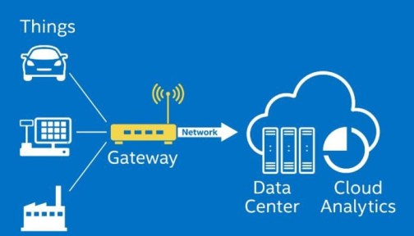http://medium.com/@darshipatel/internet-of-things-and-powerful-iot-gateways-a1673cba6cb9
Firstly, it is the second layer of the technology stack of IoT. Basically it is the connectivity between IoT devices and the cloud. In addition, it can provide offline services and real-time control over the devices in the fields. Whenever a gateway software is installed into the device, it is responsible to collect data from the sensors, pre-processing the data and sends the results to the data sensor. Moreover, a large number of manufacturers are involved in gateway design and production. Some of them are :
- Harman International Industries
- CISCO
- INTEL
- ADVANTECH
- ADLINK
Besides those gateways, data need to be stored in a local storage. Maybe, a few thousands of data are collected from the sensors. Therefore, those are needed to be stored locally before sending it to the database. So, the local storage analyzes, extracts and summarizes the data. So, the volume of data reduces and the cost of transfer and storage on the database also reduces. This kind of local storages are microcontroller and microprocessor.
Basically, the microcontroller is a computer embedded device with integrated chips which helps to pre-process the data. In addition, it consists of a processor, RAM to hold data, EPROM or flash memory to hold embedded software and cache data. Hence, IoT devices need some programmable microcontrollers to take actions on switching on or off devices. Though these decisions can also be taken by the cloud but the use of microcontroller is the safest for the health of the devices.
Above all, an open-source gateway available for IoT is Thingsboard which allows to integrate connections. In addition, it enables rapid development, management and scaling of IoT applications. Click on this to know more.

Communications
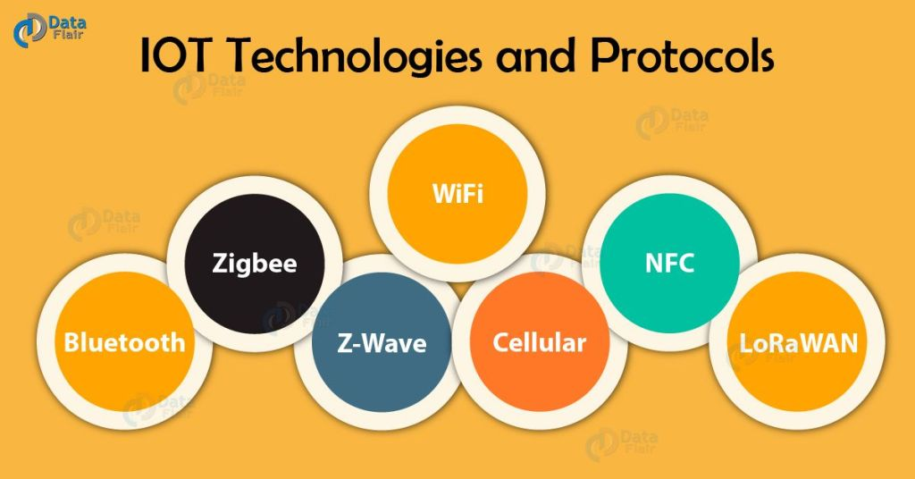IoT Protocols
Basically, internet protocols are the main connectivity protocols in IoT for communications. Across the network boundaries internet protocols suite for relaying diagrams. In addition, it functions in internetworking. Firstly, IoT gateway protocols are of two types which doesn’t require any CPU resources.
- Bus-Based: DDS, XMPP, REST
- Broker-based: AMPQ, CoAP, MQTT, JMI
Above all, there are some major protocols in IoT which can also be divided into four kinds based on their different OSI layers they are belong to
- Physical/Infrastructure
- Transport/Communication
- Data Transfer
- Device Management
Here are some commonly used IoT protocols :
- MQTT: It stands for MQ Telemetry Transport. Besides, being a simple, lightweight messaging protocol it is also for low-bandwidth, high-latency, unreliable network.
- CoAP: Constrained application protocol is a web transfer protocol designed for machine to machine applications.
- Zigbee: Basically, it is a low-cost, wireless, two-way language used for everyday devices.
- Bluetooth:
- AMQP: It stands for Advanced Message Queuing Protocol designed for business purpose.
- Z-Wave
- IPv/IPv4
- GSM

Cloud & Analytics
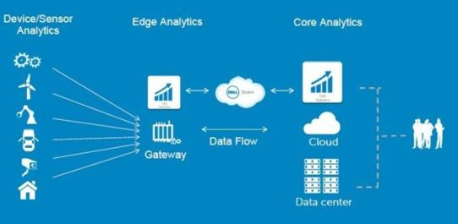https://internetofthingsagenda.techtarget.com/blog/IoT-Agenda/The-pros-and-cons-of-IoT-edge-analytics
Now, we are coming to the last layer of the technology stack of IoT. Basically this layer is responsible for the product profits of an IoT project. This layer delivers value to the customer by using strong data analysis. Basically, the cloud application combines the data collected from a lot of IoT sensors with the business data for an insight view that generates business value.
In addition, the need for a feedback loop must be there in the service platform between the manager and the customers in order to upgrade, monitor and maintain the firmware on each device. Data management, storage, tagging and analysis are increasing. So, to scale infinity the IoT service platform should be built on robust cloud infrastructure. Therefore, the growth of new product will be beneficial. The following are some IoT cloud platforms:
- Microsoft Azure
- Thingworx
- Google Cloud IoT
- IBM Watson IoT Platform
- AWS IoT Platform
- CISCO IoT cloud connect
- Thingspeak IoT platform
- Oracle IoT Platform
- Kaa IoT platform
- Predix IoT Platform
- Salesforce IoT Platform
In conclusion, the IoT technology stack is not a fixed thing. As the “things” are increasing and being smart the stack is also becoming more powerful. So, if we choose the right way to select the stack for our business it will be profitable even from a small, innovative project also.

